ABOUT YOU …

Name: Age: D.O.B: ________________Sex:______
Home Address: City/State: Zip:
Home/Cell Phone:__________ _________________________ Marital Status: ______ Spouse: _________________
Email Address: ____________________________________Social Security Number: ________________________
Preferred Language:__________________________ Race:_______________ Are you Hispanic or Latino:________
Employer: _____________________________________ Occupation:
Work Phone: Who told you about Healing Hands?
Name and No. of Emergency Contact:
Have you ever received chiropractic care? Y N With whom?
Do you have a family medical doctor? Y N Who? Date of last exam? _________________
Address: ______________________________________________________________________________________
WOMEN: Are you pregnant? Y N Date of last monthly period: ________________________________________

CURRENT HEALTH CONDITION
Current health complaints/reason for consulting our office:
1. For how long?
2. For how long?
3. For how long?
In addition to the main reason for your visit today, what additional health goals do you have? __________________ _____________________________________________________________________________________________

Were other doctors seen for this condition? Y N Who? Results:
Has this condition occurred before? Y N Are the injuries a result of an accident? Y N
If yes, how did it occur?
Please list any medications/supplements currently taking (include dosage/frequency):
Please list any allergies AND reactions to medications:
Please describe your daily activities for work, home, or school such as sitting, standing, lifting, phone use:

PAST HEALTH HISTORY

Have you had an accident, even as a passenger, in a(n): (give dates)
Automobile:______________Motorcycle:_______________Bicycle:________________Other:_________________
Medical interventions: (circle all that apply)
Hospitalizations PT Surgery Heart Appendix Hysterectomy Spinal Eye Organ removal Other
Explain with dates:

Injuries: Have you ever had…(circle all that apply)
Broken Bones Spinal/Nerve Disorder Used a crutch/walker Used Neck/Back Bracing Been Unconscious Sports Injuries
Explain with dates:
Do you consume: Alcohol Coffee/caffeine Water Intake If so how much:________________________
Please Circle your smoking status: Everyday Some Days Former Never
Exercise: None Moderate Daily

Have you had any recent vaccinations? _____ If yes, which vaccine did you receive? ___________________ Date received: _______
Did you notice any side effects? ______________________________________________________________
Have you received any COVID boosters? _____ how many? ______________ Date received: __________
Did you notice any side effects? Please list: _____________________________________________________
Have you had COVID? ________ How many times: _________ When was the last time? _____________
Have you had any long-term complaints associated with COVID? ___________________________________
Please list: _______________________________________________________________________________

Circle any of the following conditions you have had in the past six months:

Musculo-skeletal Digestive Please outline the area(s) of your

Arthritis/RA/Gout Heartburn/Acid Reflux discomfort…
Low Back Pain Diarrhea/Constipation
Neck/Arm Pain Ulcer
Shoulder Pain Frequent Nausea/Vomiting
Joint Pain/Stiffness Poor/Excessive Appetite
Knee Pain Excessive Thirst
Walking Difficulties Hemorrhoids
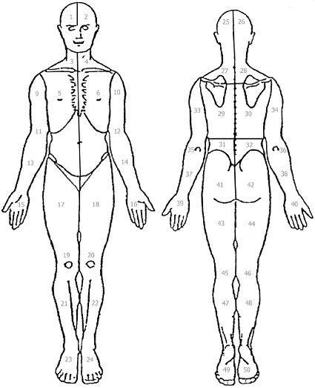
Difficulty Chewing/TMJ Liver/Gall Bladder Issues
General Stiffness Sudden Weight Change
Food Sensitivities
Nervous System IBS/GERD/Colitis
Anxiety
Headaches/Migraines
Numbness/Tingling Cardiovascular/Respiratory
Paralysis Shortness of Breath
Dizziness/Fainting High Blood Pressure
Forgetfulness High Cholesterol MS Heart Problems/Disease
Confusion/Depression Irregular Heartbeat/Pacemaker
Fibromyalgia Chest Pains
Convulsions Varicose Veins/Poor Circulation
Ankle Swelling
Sensory Emphysema/Pneumonia
Cataracts/Glaucoma Quality of Symptoms Please circle
Sore Throat/Frequent Colds what it feels like
Earaches/Hearing Trouble Urinary Numbness Burning
Stuffy Nose/Congestion Frequent Urination/Leakage Tingling Shooting
Ringing In Ears UTI Stiffness Throbbing
Kidney Stones Aching Sharp
Male/Female
Menstrual Irregularity/Cramps OTHER
PMS Diabetes
Vaginal Pain/Infections Cancer
Breast Pain/Lumps Thyroid
Prostate Issues/ED Lyme’s
Sexual Dysfunction Stroke
STD
AIDS

Signature____________________________________________________ Date__________________________

Changing the healthcare of our world!

